Unit 7 Trigonometry Exam

*28 points*

**Multiple Choice** *(6 points)*

1. 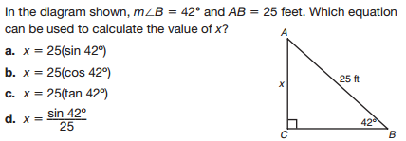
2. 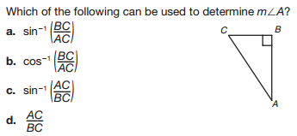
3. 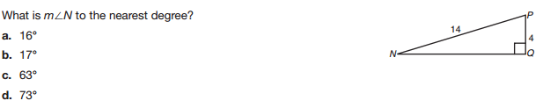

**Short Answer** *(4 points)*

1. What is the difference between sin *x* and sin–1(*x*)? _______________________________________________________________

______________________________________________________________________________________________________________________________

______________________________________________________________________________________________________________________________

______________________________________________________________________________________________________________________________

1. In a triangle, *ABC*, where angle C is 90 degrees, what is the relationship between sin A and cos B and why?

______________________________________________________________________________________________________________________________

______________________________________________________________________________________________________________________________

______________________________________________________________________________________________________________________________

______________________________________________________________________________________________________________________________

**Find the value of *x.* Express your answer in simplest radical form.** *(6 points)*

1. 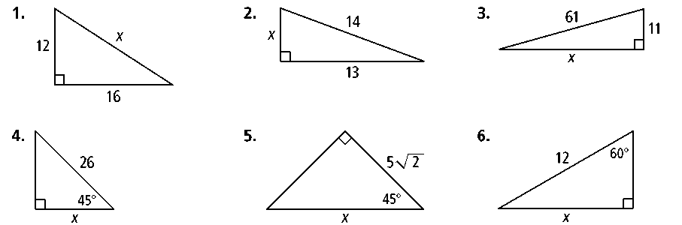

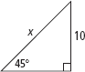

1. 

1. Find the value of *x.* Round to the nearest tenth. *(2 points)*

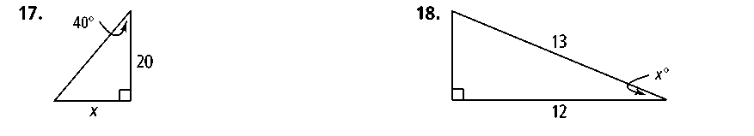

1. Find the value of *x.* Round to the nearest degree. *(2 points)*
2. The angle of depression of a vehicle on the ground from the top of a tower is 60. If the vehicle is at a distance of 100 meters away from the building, find the height of the tower to the nearest tenth of a meter. *(2 points)*
3. *(2 points)*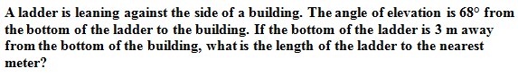

13. *(2 points)*

Screen%20Shot%202017-02-16%20at%208.49.56%20AM.png

14. *(2 points)*

